**EWAOEE Version Update – 10.12.4 (MTS)**

**Updating 9 – 10**

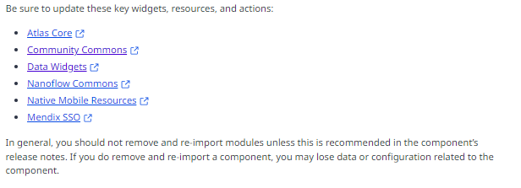

Download mendix studio pro version -10.12.4

Download the EWAOEE app from cloud, convert & run the application

Got some compilation error while running the application

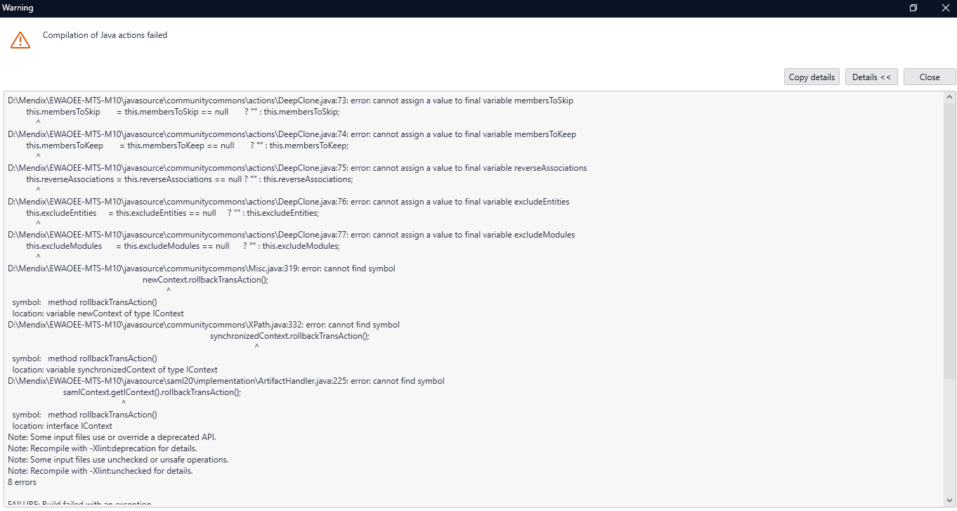Errors in

Javasource\communitycommons\actions\DeepClone.java - : error: cannot assign a value to final variable reverseAssociations

javasource\communitycommons\Misc.java:319: error: cannot find symbol - newContext.rollbackTransAction();

javasource\communitycommons\XPath.java:332: error: cannot find symbol- synchronizedContext.rollbackTransAction();

javasource\saml20\implementation\ArtifactHandler.java:225: error: cannot find symbol - samlContext.getIContext().rollbackTransAction();

**communitycommons\Misc.java**: 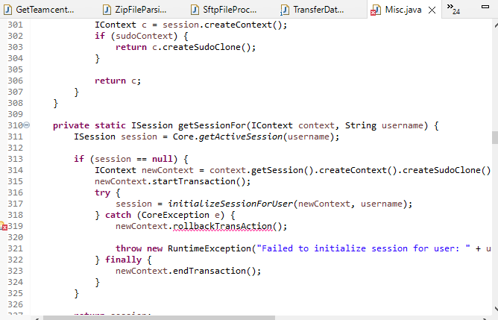

**Communitycommons\XPath.java:**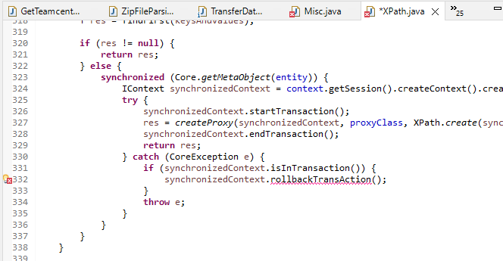

**Communitycommons\actions\DeepClone.java:**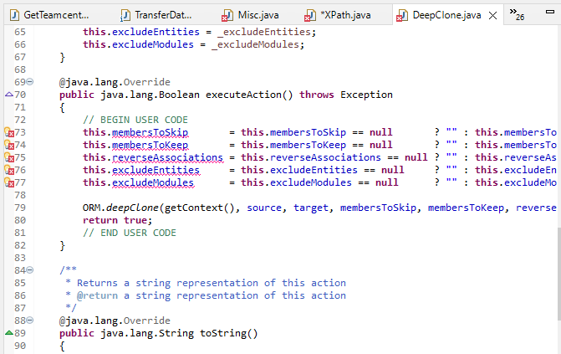

javasource\saml20\implementation\ArtifactHandler.java: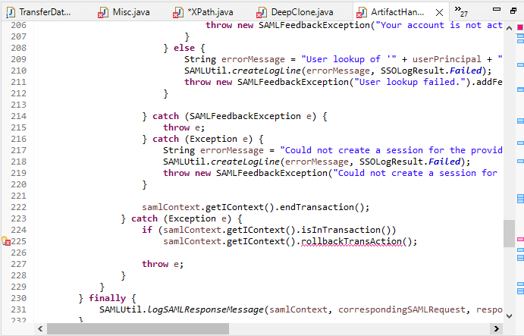

To Resolve these module error – updated community commons and run the application

Give continue to update jars

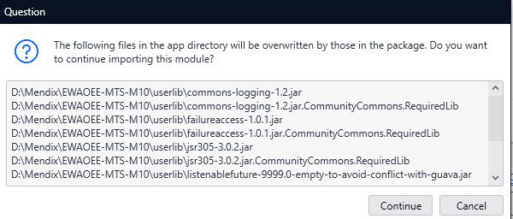

**Jars updated are:**

D:\Mendix\EWAOEE-MTS-M10\userlib\commons-logging-1.2.jar

D:\Mendix\EWAOEE-MTS-M10\userlib\commons-logging-1.2.jar.CommunityCommons.RequiredLib

D:\Mendix\EWAOEE-MTS-M10\userlib\failureaccess-1.0.1.jar

D:\Mendix\EWAOEE-MTS-M10\userlib\failureaccess-1.0.1.jar.CommunityCommons.RequiredLib

D:\Mendix\EWAOEE-MTS-M10\userlib\jsr305-3.0.2.jar

D:\Mendix\EWAOEE-MTS-M10\userlib\jsr305-3.0.2.jar.CommunityCommons.RequiredLib

D:\Mendix\EWAOEE-MTS-M10\userlib\listenablefuture-9999.0-empty-to-avoid-conflict-with-guava.jar

D:\Mendix\EWAOEE-MTS-M10\userlib\listenablefuture-9999.0-empty-to-avoid-conflict-with-guava.jar.CommunityCommons.RequiredLib

D:\Mendix\EWAOEE-MTS-M10\userlib\owasp-java-html-sanitizer-20211018.2.jar

D:\Mendix\EWAOEE-MTS-M10\userlib\owasp-java-html-sanitizer-20211018.2.jar.CommunityCommons.RequiredLib

**After updating community commons module -run**

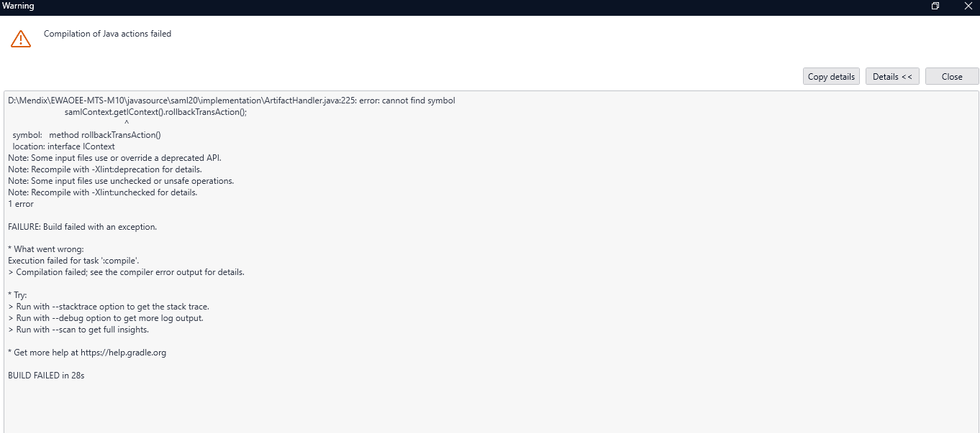Compile error from SAML20- D:\Mendix\EWAOEE-MTS-M10\javasource\saml20\implementation\ArtifactHandler.java:225: error: cannot find symbol- samlContext.getIContext().rollbackTransAction()

To resolve this update SAML module   
Updation includes:

D:\Mendix\EWAOEE-MTS-M10\resources\SAMLConfig.properties

D:\Mendix\EWAOEE-MTS-M10\resources\SAML\error.html

D:\Mendix\EWAOEE-MTS-M10\resources\SAML\templates\add-html-body-content.vm

D:\Mendix\EWAOEE-MTS-M10\resources\SAML\templates\add-html-head-content.vm

D:\Mendix\EWAOEE-MTS-M10\resources\SAML\templates\saml1-post-binding.vm

D:\Mendix\EWAOEE-MTS-M10\resources\SAML\templates\saml2-discovery-binding.vm

D:\Mendix\EWAOEE-MTS-M10\resources\SAML\templates\saml2-error-result.vm

D:\Mendix\EWAOEE-MTS-M10\resources\SAML\templates\saml2-http-ui-response.vm

D:\Mendix\EWAOEE-MTS-M10\resources\SAML\templates\saml2-post-artifact-binding.vm

D:\Mendix\EWAOEE-MTS-M10\resources\SAML\templates\saml2-post-binding.vm

D:\Mendix\EWAOEE-MTS-M10\resources\SAML\templates\saml2-post-simplesign-binding.vm

D:\Mendix\EWAOEE-MTS-M10\resources\SAML\templates\submitLoginForm.js

D:\Mendix\EWAOEE-MTS-M10\userlib\commons-codec-1.15.jar

D:\Mendix\EWAOEE-MTS-M10\userlib\commons-lang-2.6.jar

D:\Mendix\EWAOEE-MTS-M10\userlib\velocity-engine-core-2.3.jar

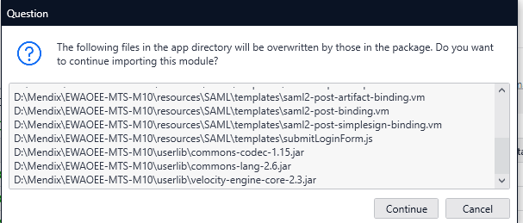

Click continue to run the application

If any errors, right click them & update all the widgets

**Run the application**

Give synchronize database to continue running

**Tables are modified from mendix9 – 10**

ALTER TABLE "mendixsystem$attribute" ADD "fkc_name" varchar(255) NULL;

ALTER TABLE "mendixsystem$association" ADD "parent_fkc_name" varchar(255) NULL;

ALTER TABLE "mendixsystem$association" ADD "child_fkc_name" varchar(255) NULL;

UPDATE "mendixsystem$version" SET "preanalysismigrationversionnumber" = '4.2.0';

ALTER TABLE "mendixsystem$attribute" DROP COLUMN "fkc_name";

ALTER TABLE "mendixsystem$association" ADD "parent_fkc_action" int2 NULL;

ALTER TABLE "mendixsystem$association" ADD "child_fkc_action" int2 NULL;

UPDATE "mendixsystem$version" SET "preanalysismigrationversionnumber" = '4.3.0';

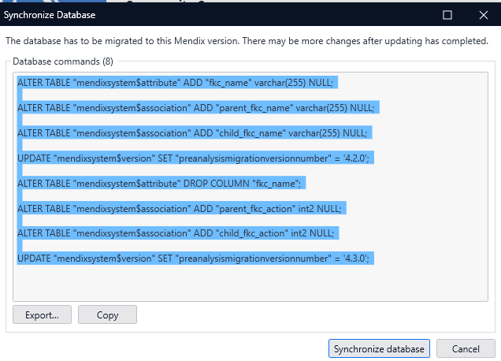**Other table also will be updated and click synchronize to continue running**

ALTER TABLE "system$workflowusertask_assignee" DROP CONSTRAINT "uniq_system$workflowusertask_assignee_system$workflowusertaskid";

DROP INDEX "idx_system$workflowusertask_assignee";

ALTER TABLE "system$workflowactivity_taskactor" DROP CONSTRAINT "uniq_system$workflowactivity_taskactor_system$workflowactivityi";

DROP INDEX "idx_system$workflowactivity_taskactor";

ALTER TABLE "system$databrokerentitymetadata" RENAME TO "88daf431f6c94482aee07c5681f7111b";ALTER TABLE "system$workflowusertask_assignee" RENAME TO "system$workflowusertask_assignees";

ALTER TABLE "system$workflowactivity_taskactor" RENAME TO "system$workflowactivity_actor";

CREATE INDEX "idx_system$workflowusertask_assignees" ON "system$workflowusertask_assignees" ("system$userid" ASC,"system$workflowusertaskid" ASC);

DELETE FROM "mendixsystem$unique_constraint" WHERE "name" = 'uniq_system$workflowusertask_assignee_system$workflowusertaskid' AND "column_id" = 'ed895e88-8fb4-3df0-b86f-faab883d19ec';

UPDATE "mendixsystem$association" SET "association_name" = 'System.WorkflowUserTask_Assignees', "table_name" = 'system$workflowusertask_assignees', "parent_entity_id" = '3729d27c-735b-457a-b210-9dffb125c3f3', "child_entity_id" = '282e2e60-88a5-469d-84a5-ba8d9151644f', "parent_column_name" = 'system$workflowusertaskid', "child_column_name" = 'system$userid', "pk_index_name" = NULL, "index_name" = 'idx_system$workflowusertask_assignees', "parent_fkc_name" = NULL, "child_fkc_name" = NULL, "parent_fkc_action" = NULL, "child_fkc_action" = NULL WHERE "id" = '929fbbed-d3a8-4ea2-b6ad-b28de4f77776';

CREATE INDEX "idx_system$workflowactivity_actor" ON "system$workflowactivity_actor" ("system$userid" ASC,"system$workflowactivityid" ASC);

ALTER TABLE "system$workflowactivity_actor" ADD CONSTRAINT "uniq_system$workflowactivity_actor_system$workflowactivityid" UNIQUE ("system$workflowactivityid");

DELETE FROM "mendixsystem$unique_constraint" WHERE "name" = 'uniq_system$workflowactivity_taskactor_system$workflowactivityi' AND "column_id" = '38f7a539-d2df-398f-99b4-047c6f7ff859';

INSERT INTO "mendixsystem$unique_constraint" ("name", "table_id", "column_id") VALUES ('uniq_system$workflowactivity_actor_system$workflowactivityid', '63446029-b863-4c07-ab91-22219be89b70', '38f7a539-d2df-398f-99b4-047c6f7ff859');

UPDATE "mendixsystem$association" SET "association_name" = 'System.WorkflowActivity_Actor', "table_name" = 'system$workflowactivity_actor', "parent_entity_id" = 'a5952592-bb2c-4798-9805-f9ff91ad97de', "child_entity_id" = '282e2e60-88a5-469d-84a5-ba8d9151644f', "parent_column_name" = 'system$workflowactivityid', "child_column_name" = 'system$userid', "pk_index_name" = NULL, "index_name" = 'idx_system$workflowactivity_actor', "parent_fkc_name" = NULL, "child_fkc_name" = NULL, "parent_fkc_action" = NULL, "child_fkc_action" = NULL WHERE "id" = '63446029-b863-4c07-ab91-22219be89b70';

ALTER TABLE "system$workflow" ADD "canapplyjumpto" bool NULL DEFAULT TRUE;

ALTER TABLE "system$workflow" ALTER "canapplyjumpto" DROP DEFAULT;

INSERT INTO "mendixsystem$attribute" ("id", "entity_id", "attribute_name", "column_name", "type", "length", "default_value", "is_auto_number") VALUES ('986e45cf-3a56-4836-8ece-53df4d3dcf9e', '2ae37bf5-ecb8-4c55-b967-d7383925b208', 'CanApplyJumpTo', 'canapplyjumpto', 10, 0, 'true', FALSE);

ALTER TABLE "system$image" ADD "enablecaching" bool NULL DEFAULT TRUE;

ALTER TABLE "system$image" ALTER "enablecaching" DROP DEFAULT;

INSERT INTO "mendixsystem$attribute" ("id", "entity_id", "attribute_name", "column_name", "type", "length", "default_value", "is_auto_number") VALUES ('0a5f1064-838e-4b91-a9c3-904428d203d2', '37827192-315d-4ab6-85b8-f626f866ea76', 'EnableCaching', 'enablecaching', 10, 0, 'true', FALSE);

ALTER TABLE "system$workflowactivity" DROP COLUMN "ismigrationactivity";

ALTER TABLE "system$workflowactivity" RENAME COLUMN "error" TO "reason";

ALTER TABLE "system$workflowactivity" ADD "actiontime" timestamp NULL;

ALTER TABLE "system$workflowactivity" ADD "detailsjson" text NULL;

DELETE FROM "mendixsystem$attribute" WHERE "id" = 'd78085f1-fdf5-40c1-93ae-30de543e4b81';

INSERT INTO "mendixsystem$attribute" ("id", "entity_id", "attribute_name", "column_name", "type", "length", "default_value", "is_auto_number") VALUES ('f3e0983a-dbe5-4287-af2d-9f455e847851', 'a5952592-bb2c-4798-9805-f9ff91ad97de', 'DetailsJson', 'detailsjson', 30, 0, '', FALSE);

INSERT INTO "mendixsystem$attribute" ("id", "entity_id", "attribute_name", "column_name", "type", "length", "default_value", "is_auto_number") VALUES ('431cc58a-fc36-427b-82e5-0751fc5fce22', 'a5952592-bb2c-4798-9805-f9ff91ad97de', 'ActionTime', 'actiontime', 20, 0, '', FALSE);

UPDATE "mendixsystem$attribute" SET "entity_id" = 'a5952592-bb2c-4798-9805-f9ff91ad97de', "attribute_name" = 'Reason', "column_name" = 'reason', "type" = 30, "length" = 0, "default_value" = '', "is_auto_number" = FALSE WHERE "id" = '3b8d6bea-dfb5-497b-b2ad-c423efbd66eb';

DELETE FROM "mendixsystem$entity" WHERE "id" = 'df86cd1e-f9ac-42d4-bcd0-a185540a247a';

DELETE FROM "mendixsystem$entityidentifier" WHERE "id" = 'df86cd1e-f9ac-42d4-bcd0-a185540a247a';

DELETE FROM "mendixsystem$sequence" WHERE "attribute_id" IN ( SELECT "id" FROM "mendixsystem$attribute" WHERE "entity_id" = 'df86cd1e-f9ac-42d4-bcd0-a185540a247a' );

DELETE FROM "mendixsystem$remote_primary_key" WHERE "entity_id" = 'df86cd1e-f9ac-42d4-bcd0-a185540a247a';

DELETE FROM "mendixsystem$attribute" WHERE "entity_id" = 'df86cd1e-f9ac-42d4-bcd0-a185540a247a';

DROP TABLE "88daf431f6c94482aee07c5681f7111b";

UPDATE "mendixsystem$version" SET "versionnumber" = '4.2', "lastsyncdate" = '20240905 06:48:49'::timestamp;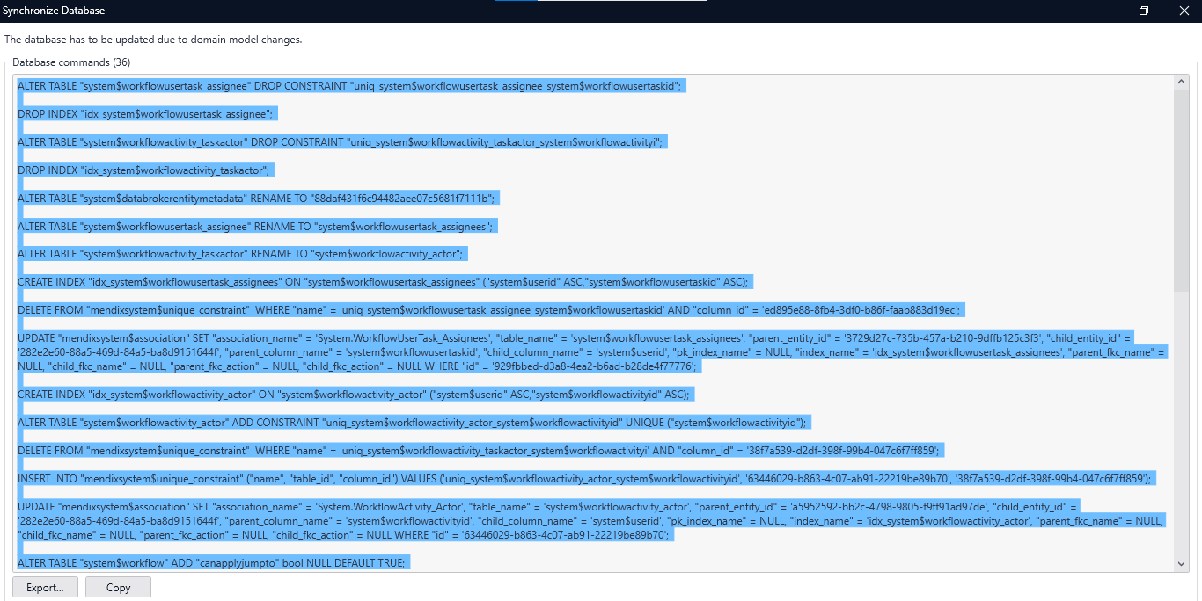ALTER TABLE "saml20$keystore" ADD "password" varchar(200) NULL;

INSERT INTO "mendixsystem$attribute" ("id", "entity_id", "attribute_name", "column_name", "type", "length", "default_value", "is_auto_number") VALUES ('601cc18e-7c60-4a35-a3b7-25b63c9b9b9a', '4d8cf867-8411-43f0-9b8b-86d32f6153b5', 'Password', 'password', 30, 200, '', FALSE);

ALTER TABLE "saml20$ssoconfiguration" ADD "useencryption" bool NULL DEFAULT TRUE;

ALTER TABLE "saml20$ssoconfiguration" ALTER "useencryption" DROP DEFAULT;

ALTER TABLE "saml20$ssoconfiguration" ADD "encryptionkeylength" varchar(19) NULL DEFAULT '_2048bit_Encryption';

ALTER TABLE "saml20$ssoconfiguration" ALTER "encryptionkeylength" DROP DEFAULT;

ALTER TABLE "saml20$ssoconfiguration" ADD "isuploadnewkeypair" bool NULL DEFAULT FALSE;

ALTER TABLE "saml20$ssoconfiguration" ALTER "isuploadnewkeypair" DROP DEFAULT;

ALTER TABLE "saml20$ssoconfiguration" ADD "encryptionmethod" varchar(13) NULL DEFAULT 'SHA256WithRSA';

ALTER TABLE "saml20$ssoconfiguration" ALTER "encryptionmethod" DROP DEFAULT;

ALTER TABLE "saml20$ssoconfiguration" ALTER COLUMN "currentwizardstep" TYPE varchar(6);

UPDATE "mendixsystem$attribute" SET "entity_id" = '884aea19-be88-4816-bb59-ed1e54c18b23', "attribute_name" = 'CurrentWizardStep', "column_name" = 'currentwizardstep', "type" = 40, "length" = 6, "default_value" = 'Step1', "is_auto_number" = FALSE WHERE "id" = '389cc4c4-9d82-417d-99da-d9829ee57adb';

INSERT INTO "mendixsystem$attribute" ("id", "entity_id", "attribute_name", "column_name", "type", "length", "default_value", "is_auto_number") VALUES ('d7da17dc-62d5-4794-88a8-37ebdeca2186', '884aea19-be88-4816-bb59-ed1e54c18b23', 'UseEncryption', 'useencryption', 10, 0, 'true', FALSE);

INSERT INTO "mendixsystem$attribute" ("id", "entity_id", "attribute_name", "column_name", "type", "length", "default_value", "is_auto_number") VALUES ('e0be6e00-e150-44ac-a345-68428899fb4b', '884aea19-be88-4816-bb59-ed1e54c18b23', 'EncryptionMethod', 'encryptionmethod', 40, 13, 'SHA256WithRSA', FALSE);

INSERT INTO "mendixsystem$attribute" ("id", "entity_id", "attribute_name", "column_name", "type", "length", "default_value", "is_auto_number") VALUES ('20a714d8-c00d-46f5-bc6e-e7c18ddb7043', '884aea19-be88-4816-bb59-ed1e54c18b23', 'EncryptionKeyLength', 'encryptionkeylength', 40, 19, '_2048bit_Encryption', FALSE);

INSERT INTO "mendixsystem$attribute" ("id", "entity_id", "attribute_name", "column_name", "type", "length", "default_value", "is_auto_number") VALUES ('f841f46b-e4e4-43ac-8dde-04a2450690d8', '884aea19-be88-4816-bb59-ed1e54c18b23', 'isUploadNewKeyPair', 'isuploadnewkeypair', 10, 0, 'false', FALSE);

CREATE TABLE "saml20$ssoconfiguration_keystore" (

"saml20$ssoconfigurationid" int8 NOT NULL,

"saml20$keystoreid" int8 NOT NULL,

PRIMARY KEY("saml20$ssoconfigurationid","saml20$keystoreid"),

CONSTRAINT "uniq_saml20$ssoconfiguration_keystore_saml20$keystoreid" UNIQUE ("saml20$keystoreid"),

CONSTRAINT "uniq_saml20$ssoconfiguration_keystore_saml20$ssoconfigurationid" UNIQUE ("saml20$ssoconfigurationid"));

CREATE INDEX "idx_saml20$ssoconfiguration_keystore" ON "saml20$ssoconfiguration_keystore" ("saml20$keystoreid" ASC,"saml20$ssoconfigurationid" ASC);

INSERT INTO "mendixsystem$association" ("id", "association_name", "table_name", "parent_entity_id", "child_entity_id", "parent_column_name", "child_column_name", "index_name") VALUES ('22988c4a-b3b0-4f5f-a044-2d5f50185db0', 'SAML20.SSOConfiguration_KeyStore', 'saml20$ssoconfiguration_keystore', '884aea19-be88-4816-bb59-ed1e54c18b23', '4d8cf867-8411-43f0-9b8b-86d32f6153b5', 'saml20$ssoconfigurationid', 'saml20$keystoreid', 'idx_saml20$ssoconfiguration_keystore');

INSERT INTO "mendixsystem$unique_constraint" ("name", "table_id", "column_id") VALUES ('uniq_saml20$ssoconfiguration_keystore_saml20$keystoreid', '22988c4a-b3b0-4f5f-a044-2d5f50185db0', 'a789167e-f2ba-3136-a7fd-93e4b25b74b4');

INSERT INTO "mendixsystem$unique_constraint" ("name", "table_id", "column_id") VALUES ('uniq_saml20$ssoconfiguration_keystore_saml20$ssoconfigurationid', '22988c4a-b3b0-4f5f-a044-2d5f50185db0', '98881de4-4d42-30b5-b509-06cf9e66eda4');

CREATE TABLE "saml20$keyinfo_keyinfo" (

"saml20$keyinfoid1" int8 NOT NULL,

"saml20$keyinfoid2" int8 NOT NULL,

PRIMARY KEY("saml20$keyinfoid1","saml20$keyinfoid2"),

CONSTRAINT "uniq_saml20$keyinfo_keyinfo_saml20$keyinfoid1" UNIQUE ("saml20$keyinfoid1"));

CREATE INDEX "idx_saml20$keyinfo_keyinfo_saml20$keyinfo_saml20$keyinfo" ON "saml20$keyinfo_keyinfo" ("saml20$keyinfoid2" ASC,"saml20$keyinfoid1" ASC);

INSERT INTO "mendixsystem$association" ("id", "association_name", "table_name", "parent_entity_id", "child_entity_id", "parent_column_name", "child_column_name", "index_name") VALUES ('6716cf13-63ca-44b1-b991-d917e421b0fd', 'SAML20.KeyInfo_KeyInfo', 'saml20$keyinfo_keyinfo', '3453ef38-65f1-43b3-b2ab-bbbb1fc6a833', '3453ef38-65f1-43b3-b2ab-bbbb1fc6a833', 'saml20$keyinfoid1', 'saml20$keyinfoid2', 'idx_saml20$keyinfo_keyinfo_saml20$keyinfo_saml20$keyinfo');

INSERT INTO "mendixsystem$unique_constraint" ("name", "table_id", "column_id") VALUES ('uniq_saml20$keyinfo_keyinfo_saml20$keyinfoid1', '6716cf13-63ca-44b1-b991-d917e421b0fd', '3e6324a8-d3d5-34ef-9707-d88fb6a8e13e');

UPDATE "mendixsystem$version" SET "versionnumber" = '4.2', "lastsyncdate" = '20240905 10:27:03'::timestamp;

After Synchronizing app ran successfully

**Login and test all the usecase are working fine as in mendix 9**

Check all the functionalities involved - Dashboard, create asset, import timerseries data, do aggregation, dafa functionality,cleanUp functionality,Check all the overview and log pages, import timeseries through sftp to webservices usecase

SAML can't be tested in local

In Overview pages that have data grids – pagination is missing

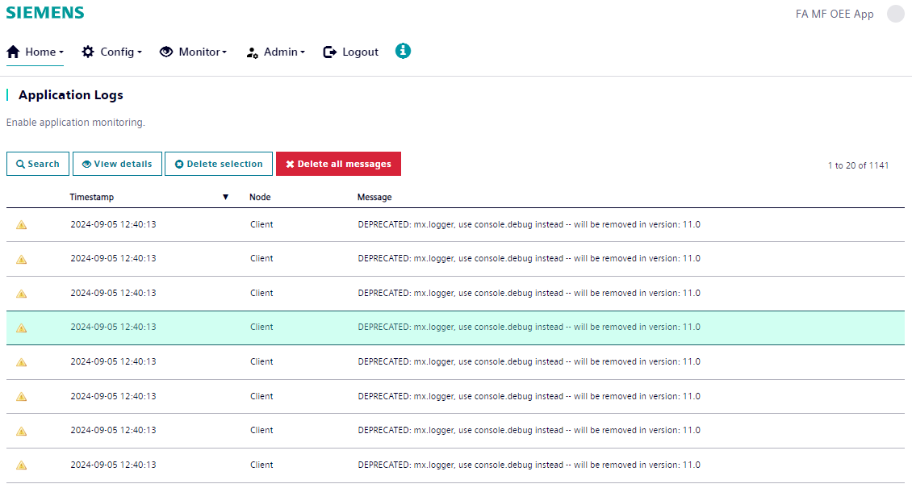

To resolve this, updated Data Widget module - for layout & pagination icons

Update Nanoflow commons and run

Updation includes:

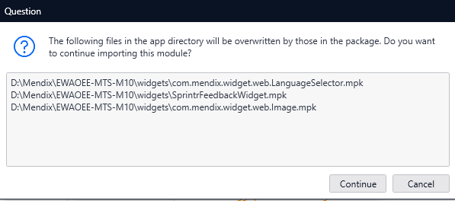

After updating , will get errors

Simply right click those error and update all the widgets and run the application

Run & check the UI

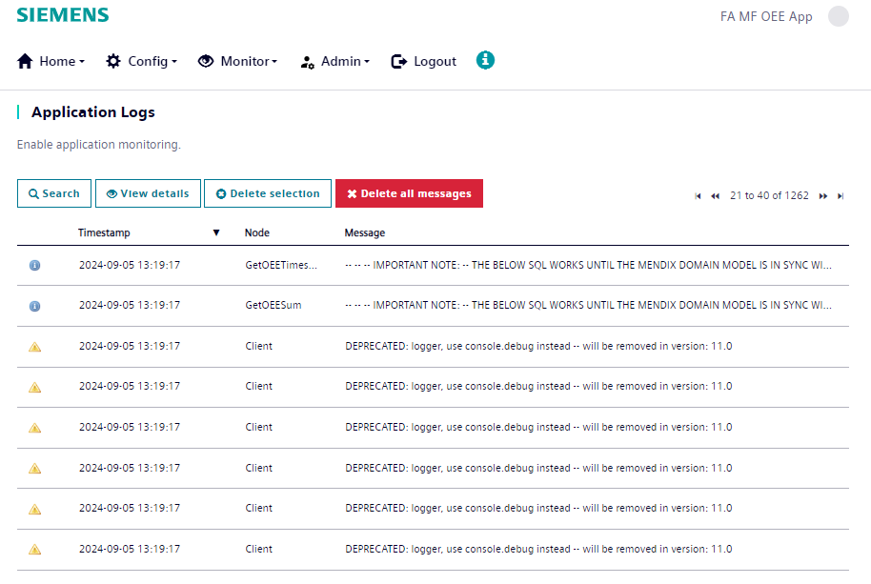------------------------------------------------------------------------------------------------------------------

From this there was issue in layout,copyToClipboard

To Sort all:

Converted the app & updated following modules to achieve the expected application

**1.Community Commons**

**2.SAML**

**3.Data Widgets (Atlas core, Atlas web content)**

**4.Nanoflow commons**

**5. Import Atlas & Atlas filled folder from mendix 10 new app - ( for pagination issue)**

**6. Used SiemensResource copyClipboard instead of deeplink copyClipboard beacase deeplink is deprecated in mendix latest versions - (for link copyClipboard issue)**

Run & test the existing functionality

1 Asset creation & import timeseries data - Done

2 Import Timeseries from cron – Done

3 DashBoards – Done

4 SnowFlake & Dafa Transfer – Done

5 OEE Aggregation – manual & automatic - Done

6 Export timeseries & OEE Aggregation, user account - Done

7. CleanUp done - (scheduled)

8. Deeplink (dashboard & documentations) - Done

9.CycleTimeCorrection - Done

10. OutOfOrder Setection - Done